Customize a JavaScript Calendar

Take this as your starting point –

<https://javascript.info/task/calendar-table>

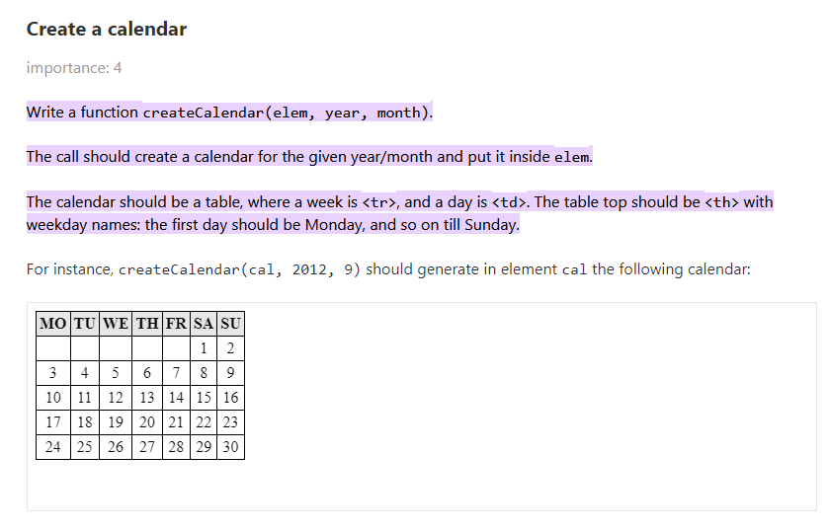

Using the codebase, update the same calendar to display like this –

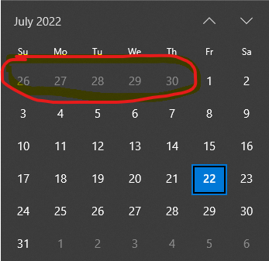

**Highlight Today – as above or below**

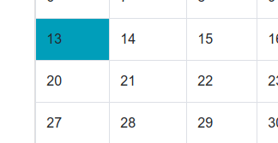

**Apply Prev | Next like this to get calendar of next or previous month**

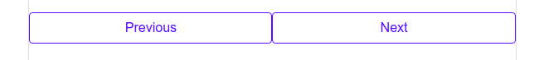

You can take help from this article - <https://medium.com/@nitinpatel_20236/challenge-of-building-a-calendar-with-pure-javascript-a86f1303267d>

**Refactor the code: Once you have come out with a working version then refactor the JavaScript code to make the readability and usability better.**